# MCBMini v4.4 – Scalable and Flexible Motor Control

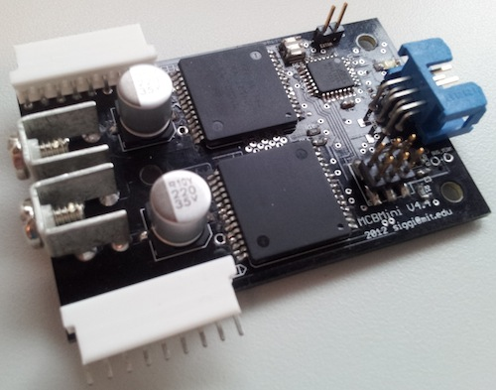

The aim of the MCBMini Motor Control System is to provide a low-cost and low-effort way to do scalable and flexible motor control. What we mean by “scalable” and “flexible” is that the system should easily support a user in quickly testing out a prototype project, which requires minimal configuration and setup, while also providing support for more involved projects which require a larger number of motors with more specific configuration.

This product generally requires an MCBCom board to function (also available on this website). A typical application could be a stack of three MCBMini boards, with an MCBCom board on top which communicates with a computer (this would allow control of six motors). This is the recommended use case and provides significant convenience but there is a way to use the MCBMini boards without an MCBCom board with minimal modification (at the cost of robustness).

## Main Features

Each MCBMini board has two channels which can each control a brushed DC motor using PID closed loop control with either potentiometer or quadrature encoder feedback.

### General project features:

* The whole project has been open sourced so all design materials are available (pcb design, firmware and host software) here: <https://code.google.com/p/mcbmini/>
* Java software exists for interfacing with the controllers either via Graphical User Interface (GUI) or through a software API
* Configuration of the motors can be done on-line through the GUI for testing purposes or through an XML configuration file
* Status LED communicates the several states the board can be in (uninitialized, enabled/disabled, fault)
* Communications bus uses RS485 which adds noise immunity by using differential signals
* Power-ground and logic-ground are maintained separate on each MCBMini board (should be joined in one spot such as on the MCBCom board or manually) to avoid ground loops.

### Board channel features:

* PWM frequency is 20kHz which minimizes audible humming
* Quadrature encoder or potentiometer feedback for PID
  + The quadrature feedback is currently limited to phase pulse trains of < 11kHz. This is because the quadrature decoding happens in interrupt routines and can only be processed so fast before it starts affecting the performance of the board. We have plans to fix this in a future version of the board by using a microcontroller with hardware quadrature decoding.
* Velocity, position and mixed modes available
  + Mixed mode uses a position PID loop around a velocity PID loop (this allows velocity limiting in position mode)
  + Velocity limits available in velocity and mixed mode
* Extra pin which can be configured as:
  + A servo controller (generate the specific PWM signal needed to control a servo motor)
  + A digital input pin which can be useful for limit switches
  + An analog input pin which can be used to read an external sensor
  + A resistor can be added to the board to hardwire the extra pins to measure either the logic or motor battery voltages through a voltage divider
* Electrical motor current is measured and reported
* Fault messages and bridge disabling on several fault conditions, which the H-bridge generates (short circuit on output, over temperature etc.)
* The current value of any board parameter can be retrieved or reported. The most useful ones are “actual position”, “actual velocity”, “potentiometer value” etc.

## Electrical Specifications

The MCBMini board has two H-bridge chips (part number VNH5019A-E from ST Microelectronics). The specifications are mostly dependent on the specs of that device while being de-rated by temperature considerations (connectors, trace widths etc.)

Here are the specs of the VNH5019A-E device:

* Operating bridge supply voltage 5.5V - 24V
* Maximum output current (continuous) 30A (note that for high current applications, special connectors and wires should be used as well as heat-sinks)
* RDS(on) 18mOhm per leg
* Undervoltage and overvoltage shutdown
* High-side and low-side thermal shutdown
* Current limitation

## Control Software

The MCBMini boards can be fully controlled and configured through a Graphical User Interface as well as programmatically through a Java API.

## Screenshots from GUI:

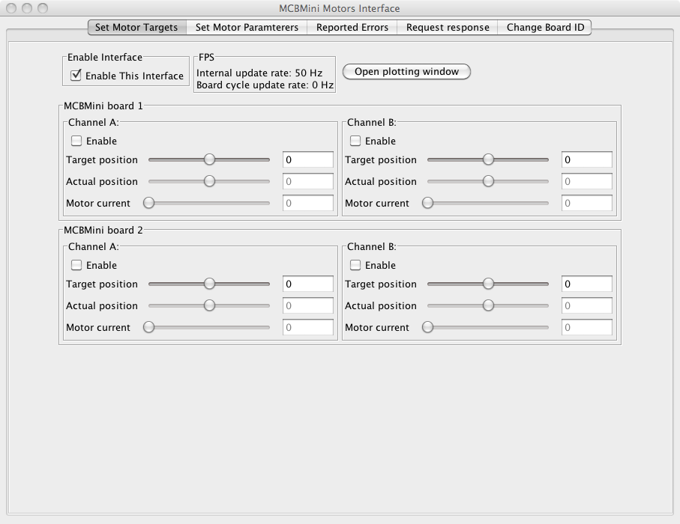

This is the main motor target window where a user can specify motor target positions or velocities and observe instantaneous feedback values.

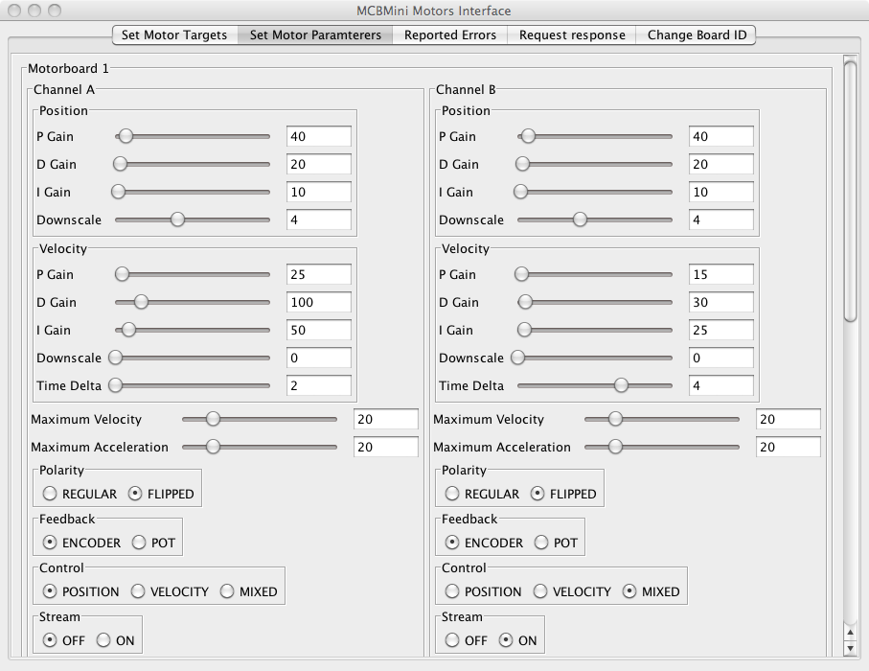

In this window the user can specify various parameters for the boards and change them on the fly. These parameters are read from a configuration XML file.

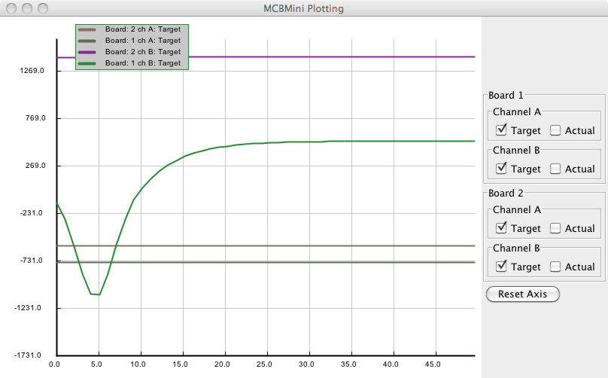

In this window the user can observe target and actual values for all the controllers. This is often crucial to tune the controllers for different setups.